DATABASE SYSTEMS ASSIGNMENT 3

Name-Vinayak Raghupathy

NYUID-N11568565

NETID-VR840

Q1) Consider the ER diagram in Figure 3.21, which shows a simplified schema

for an airline reservations system. Extract from the ER diagram the requirements

and constraints that produced this schema. Try to be as precise as

possible in your requirements and constraints specification.

Ans 1) The database here represents each AIRPORT, which has a unique Airport code, the airport name, and the city and state in which the airport is located.

Each FLIGHT of the airline has a unique flight number, the airline for the FLIGHT, and the weekdays on which the flight can be scheduled. A flight is composed of one or more FLIGHT LEG’s evident from the 1:N relationship. Each flight leg has a DEPARTURE & ARRIVAL AIRPORTS and scheduled Departure time and scheduled Arrival time.

A LEG INSTANCE is an instance of a FLIGHT LEG on a specific Date for example ABX112 leg 1 on July 26, 1990 . The actual departure and arrival airports and the arrival and departure times are recorded for each flight leg after the flight leg has been concluded. The

number of available seats and the airplane used in the LEG INSTANCE are also kept.

The customer RESERVATION’s on each LEG INSTANCE contains the customer name, phone, and seat numbers for each reservation.

Information about AIRPLANE’s and AIRPLANE TYPE’s are also kept. For each AIRPLANE

TYPE (for example, US-90), the type name, manufacturing company, and

maximum number of seats allowed are also kept. The airports in which planes of this type

CAN LAND also also kept in the database. For each airplane the Airplane id, total number of seats, and type are kept.

Q2) A database is being constructed to keep track of the teams and games of a

sports league. A team has a number of players, not all of whom participate in

each game. It is desired to keep track of the players participating in each

game for each team, the positions they played in that game, and the result of

the game. Design an ER schema diagram for this application, stating any

assumptions you make. Choose your favorite sport (e.g., soccer, baseball,

football).

Ans2)

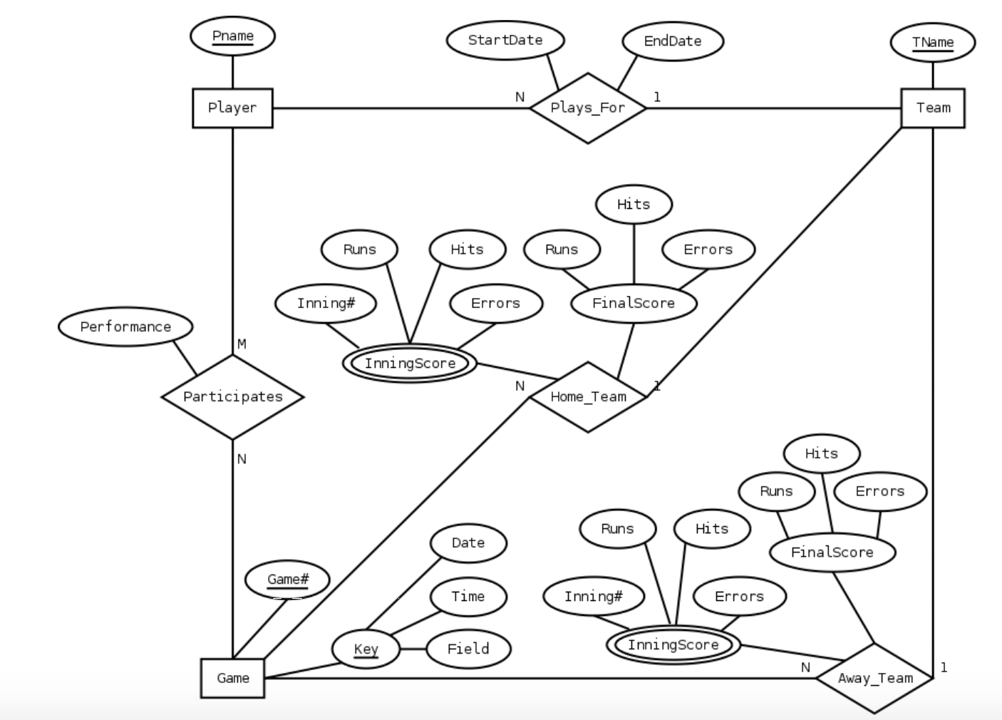

The following design may be used for a baseball league. Here, we assumed that each game in the schedule is identified by a unique game#, and a game is also identified uniquely by the combination of date, starting time, and field where game is played.

The performance attribute of PARTICIPATE is used to store data about the individual performance of each player in a game. This attribute can be designed to keep the information required for statistics, and can be quite complicated.

One possible design for the Performance attribute may be the following Performance( {Hitting(AtBat#, Inning#, Type_hit, Runs, RunsBattedIn, StolenBases)}, {Pitching(Inning#, Hits, Runs, Earned_Runs, StrikeOuts, Walks, Outs, Balks, WildPitches)}, {Defense(Inning#, {FieldingRecord(Position, Put_outs, Assists, Errors)})} )

Here, performance is a composite attribute made up of three multivalued components:

Hitting- has a value for each AtBat of a player

Pitching- has a value for each inning during which the player pitched.

Defense- has a value for each inning a player had a fielding position.

And record hit type for example,

Single=1,

Double=2,

Triple=3

Home Run=4 and

Strike=-1 and other data concerning the AtBat.

We can add more information to this performance attribute if there is storage available.

Q3) Consider the ER diagram in Figure 3.24. Assume that a course may or may

not use a textbook, but that a text by definition is a book that is used in some

course. A course may not use more than five books. Instructors teach from

two to four courses. Supply (min, max) constraints on this diagram. *State*

*clearly any additional assumptions you make.* If we add the relationship

ADOPTS, to indicate the textbook(s) that an instructor uses for a course,

should it be a binary relationship between INSTRUCTOR and TEXT, or a

ternary relationship among all three entity types? What (min, max) constraints

would you put on the relationship? Why?

Ans3) Assuming the following additional assumptions:

An instructor can teach exactly one course.

Each textbook is used by one and only one course.

An instructor does not have to adopt a textbook for all courses.

If a text exists it is used in some course is adopted by some instructor who teaches that

course.

An instructor is considered to adopt a text if it is used in some course taught by that instructor.

The resulting ER diagram with min and max constraints are-

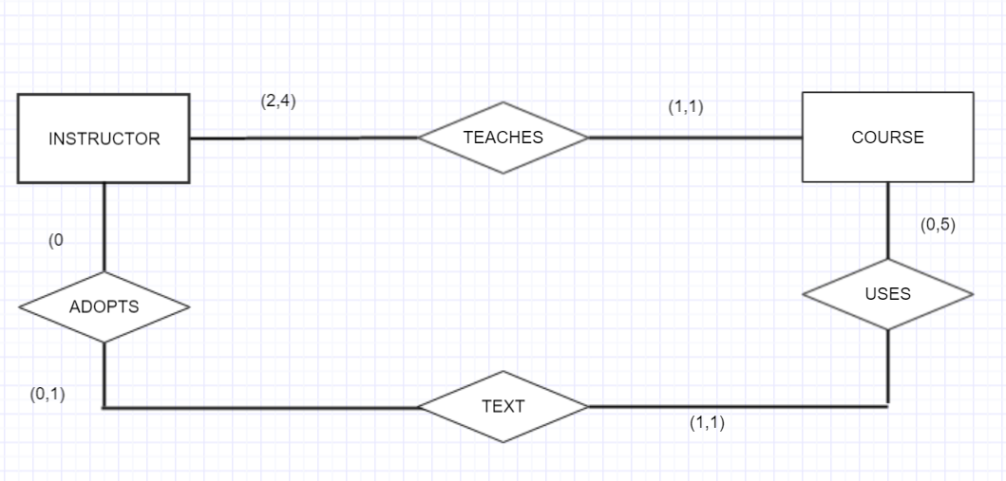

Q4) Illustrate the UML diagram for Exercise 3.16. Your UML design should

observe the following requirements:

a. A student should have the ability to compute his/her GPA and add or

drop majors and minors.

b. Each department should be able to add or delete courses and hire or terminate

faculty.

c. Each instructor should be able to assign or change a student’s grade for a

course.

Ans4) 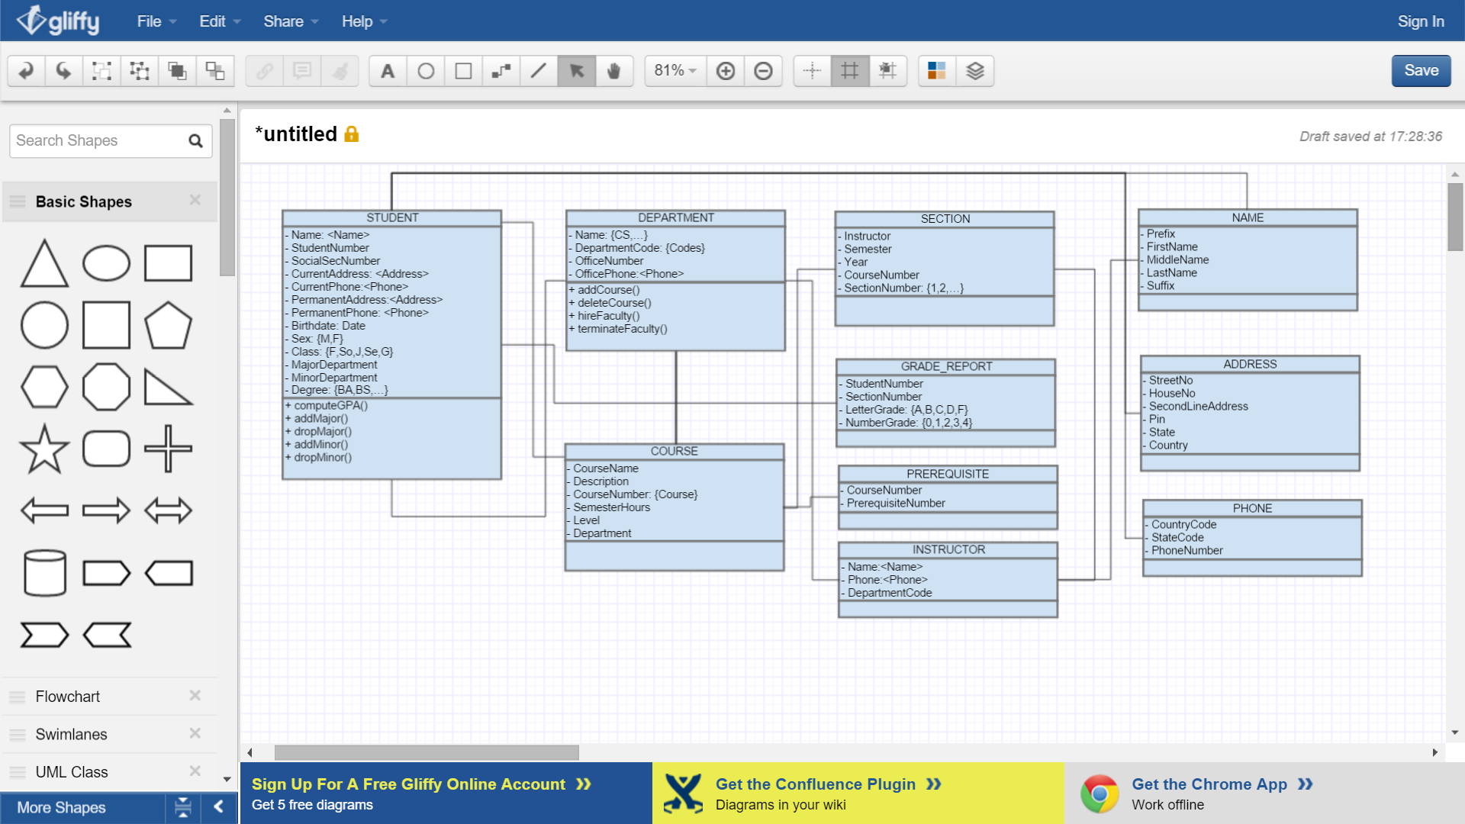

Q5) Identify all the important concepts represented in the library database case

study described below. In particular, identify the abstractions of classification

(entity types and relationship types), aggregation, identification, and

specialization/generalization. Specify (min, max) cardinality constraints

whenever possible. List details that will affect the eventual design but that

have no bearing on the conceptual design. List the semantic constraints separately.

Draw an EER diagram of the library database.

Ans 5)

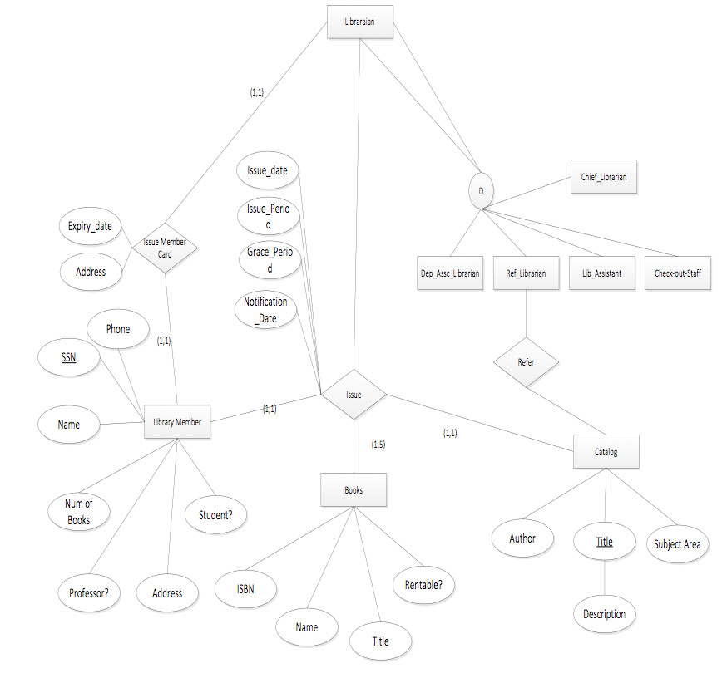

Q6) Figure 4.12 shows an example of an EER diagram for a small-private-airport

database; the database is used to keep track of airplanes, their owners, airport

employees, and pilots. From the requirements for this database, the following

information was collected: Each AIRPLANE has a registration number

[Reg#], is of a particular plane type [OF_TYPE], and is stored in a particular

hangar [STORED_IN]. Each PLANE_TYPE has a model number [Model], a

capacity [Capacity], and a weight [Weight]. Each HANGAR has a number

[Number], a capacity [Capacity], and a location [Location]. The database also

keeps track of the OWNERs of each plane [OWNS] and the EMPLOYEEs who

have maintained the plane [MAINTAIN]. Each relationship instance in OWNS

relates an AIRPLANE to an OWNER and includes the purchase date [Pdate].

Each relationship instance in MAINTAIN relates an EMPLOYEE to a service

record [SERVICE]. Each plane undergoes service many times; hence, it is

related by [PLANE_SERVICE] to a number of SERVICE records. A SERVICE

record includes as attributes the date of maintenance [Date], the number of

hours spent on the work [Hours], and the type of work done [Work_code]. We

use a weak entity type [SERVICE] to represent airplane service, because the

airplane registration number is used to identify a service record. An OWNER

is either a person or a corporation. Hence, we use a union type (category)

[OWNER] that is a subset of the union of corporation [CORPORATION] and

person [PERSON] entity types. Both pilots [PILOT] and employees

[EMPLOYEE] are subclasses of PERSON. Each PILOT has specific attributes

license number [Lic_num] and restrictions [Restr]; each EMPLOYEE has specific

attributes salary [Salary] and shift worked [Shift]. All PERSON entities in

the database have data kept on their Social Security number [Ssn], name

[Name], address [Address], and telephone number [Phone]. For CORPORATION

entities, the data kept includes name [Name], address [Address], and

telephone number [Phone]. The database also keeps track of the types of

planes each pilot is authorized to fly [FLIES] and the types of planes each

employee can do maintenance work on [WORKS_ON]. Show how the

SMALL_AIRPORT EER schema in Figure 4.12 may be represented in UML

notation. (*Note*: We have not discussed how to represent categories (union

types) in UML, so you do not have to map the categories in this and the following

question.)

Ans 6)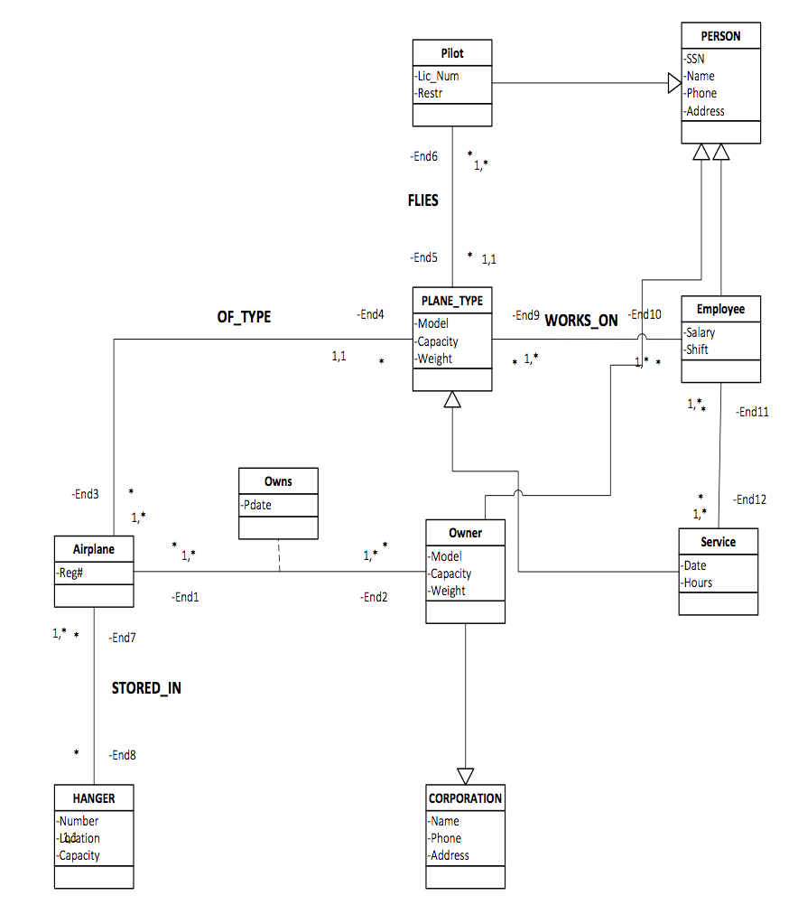

Q7) Which of the following EER diagrams is/are incorrect and why? State clearly

any assumptions you make.

Ans7)Well out of all EER diagrams, c is incorrect as we can see that the entity E1 belongs to a group subset entity E3 This means it is a subclass or subtype of the E3 entity type, and the E3 entity type is the superclass or supertype for E1. vice versa we can also say where E3 is the subclass of E1 which is not possible, this it is incorrect.